**WorkSheet:- 3.2**

**Student Name:** Vivek Kumar **UID:** 21BCS8129

**Branch:** BE-CSE (LEET) **Section/Group:** 20BCS-809/A

**Semester:** 4th Sem **Date of Performance:** 30/04/2022

**Subject Name:** SE Lab **Subject Code:** 20CSP-255

**AIM: - Design a structure chart for a student registration process who is taking admission in a college/university.**

**Requirement Analysis:**

**Software Requirement**

* Windows10 / Mac-OS
* Chrome/Firefox/Safari Browser
* App.diagrams.net website

**Hardware requirement**

* + Computer / laptop
  + Power supply

**Solution: -** **Structure Chart** represent hierarchical structure of modules. It breaks down the entire system into lowest functional modules, describe functions and sub-functions of each module of a system to a greater detail. Structure Chart partitions the system into black boxes (functionality of the system is known to the users but inner details are unknown). Inputs are given to the black boxes and appropriate outputs are generated.

Modules at top level called modules at low level. Components are read from top to bottom and left to right. When a module calls another, it views the called module as black box, passing required parameters and receiving results.

**Structure Chart:**

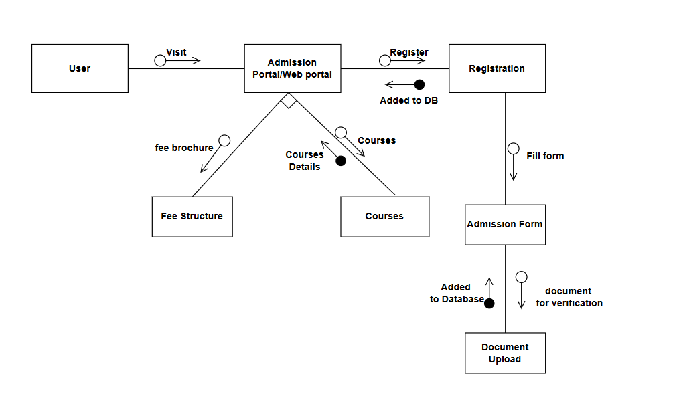

**Description:** Here when the student/user visit the website of any college or universities or their admission portal. They will get the Fee structure and courses access and then they can select the Course for further process. After selecting course, they have to registration fill the admission form then upload the required documents. It will get added to the Database.

**Evaluation Grid (To be created as per the SOP and Assessment guidelines by the faculty):**

|  |  |  |  |
| --- | --- | --- | --- |
| Sr. No. | Parameters | Marks Obtained | Maximum Marks |
| 1. |  |  |  |
| 2. |  |  |  |
| 3. |  |  |  |
| 4. |  |  |  |